Reading online resources:
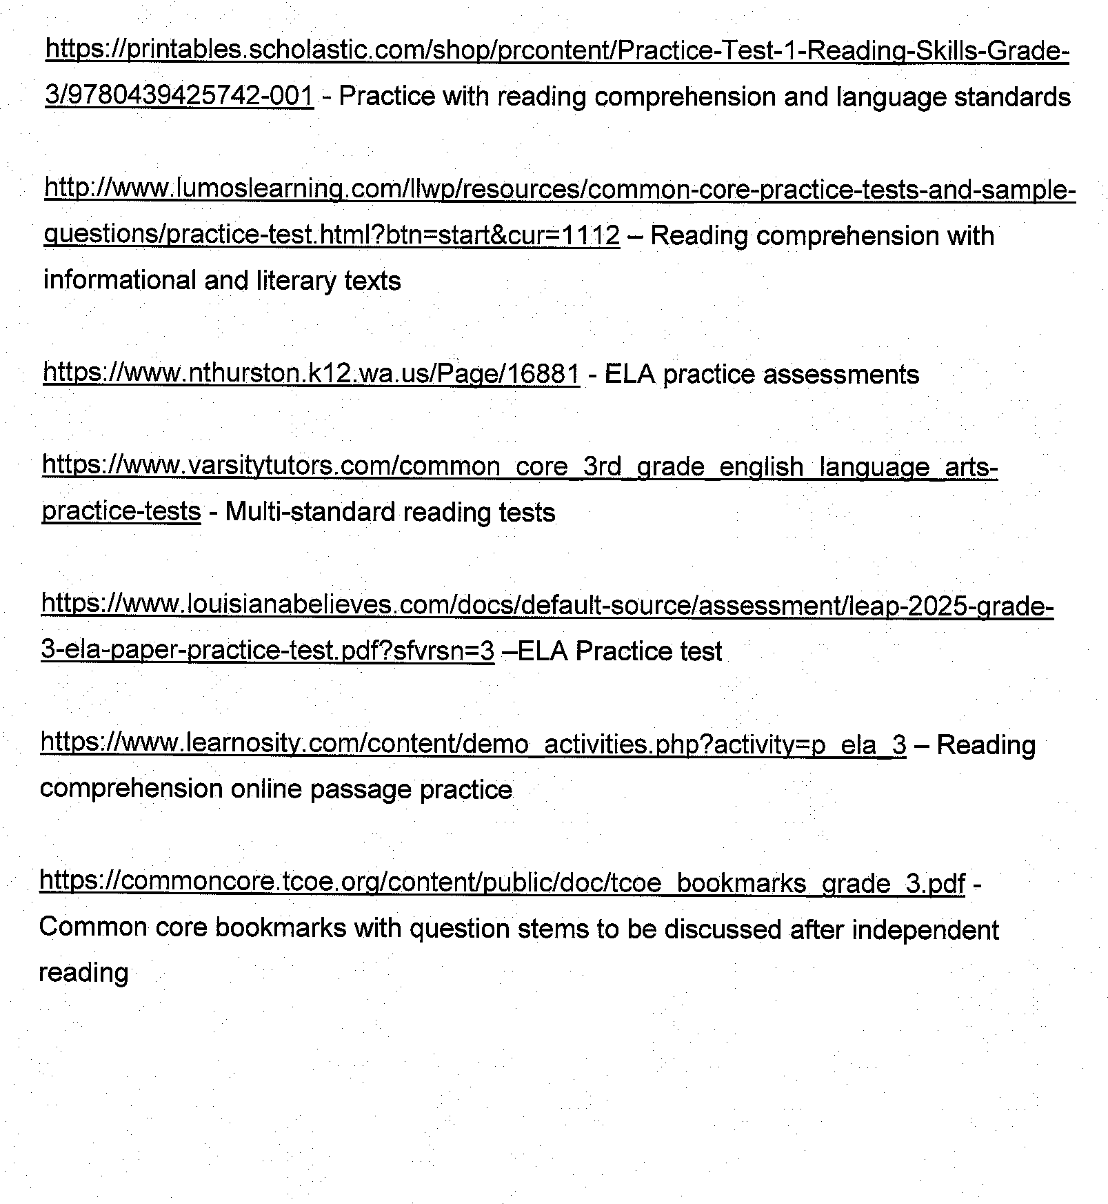

Math online resources:

https://www.ixl.com/math/grade-3 - lots of topics to choose from, up to 20 free questions a day

https://www.eduplace.com/kids/mw/practice/ep_3.html - miscellaneous third grade review

https://www.mathabc.com/math-3rd-grade - all third grade topics

http://www.mathplayground.com/grade_3_games.html - lots of online games

http://www.mathgametime.com/grade/3rd-grade - games, videos, and worksheets all on this site

http://math4children.com/Grade3/quizzes/index.html - interactive math quizzes, great for test prep practice!

